Question 1:

Find out the mail servers of the following domain :

Ibm.com

Wipro.com

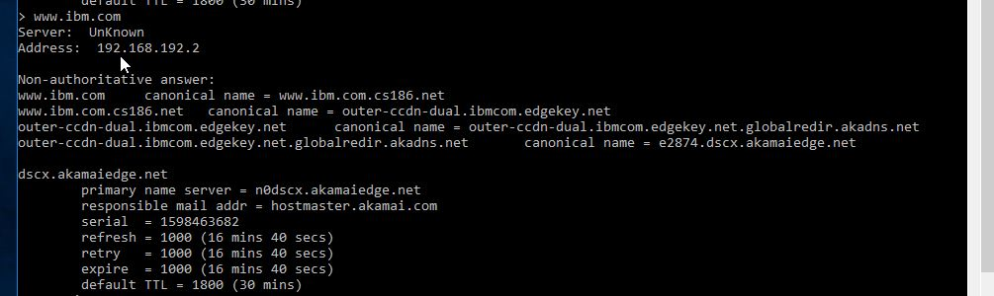

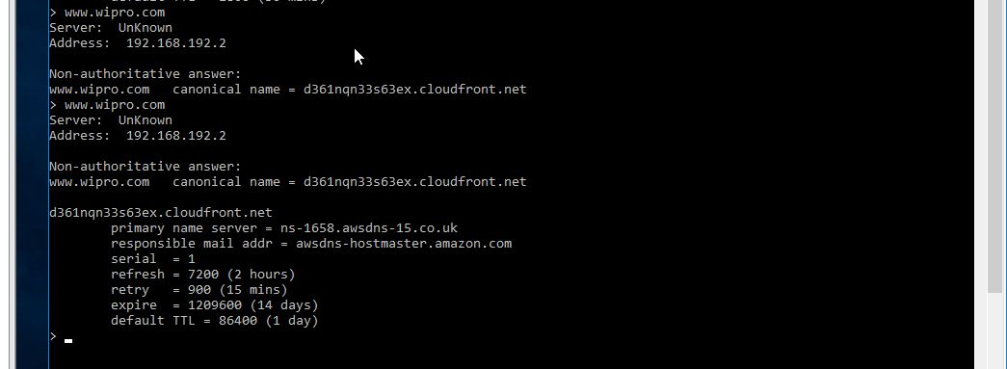

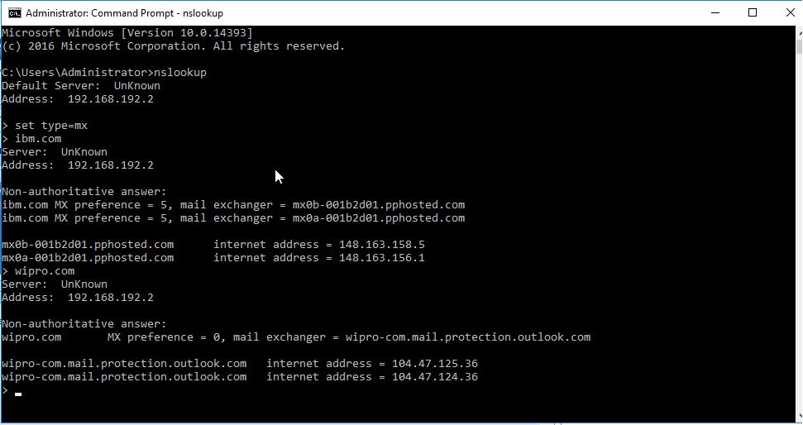

Question 2:

Find the locations, where these email servers are hosted.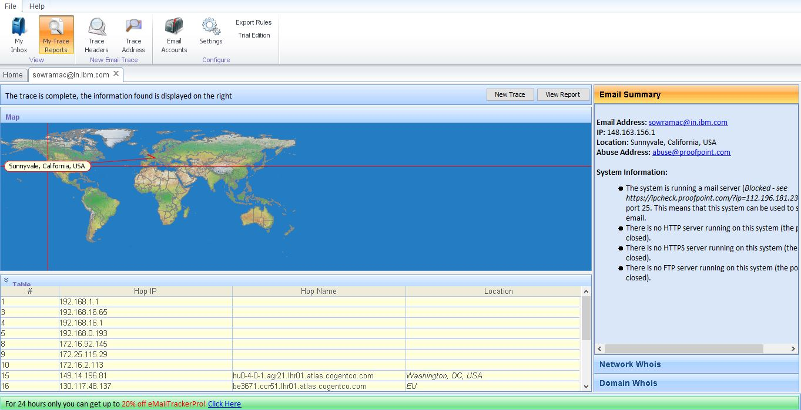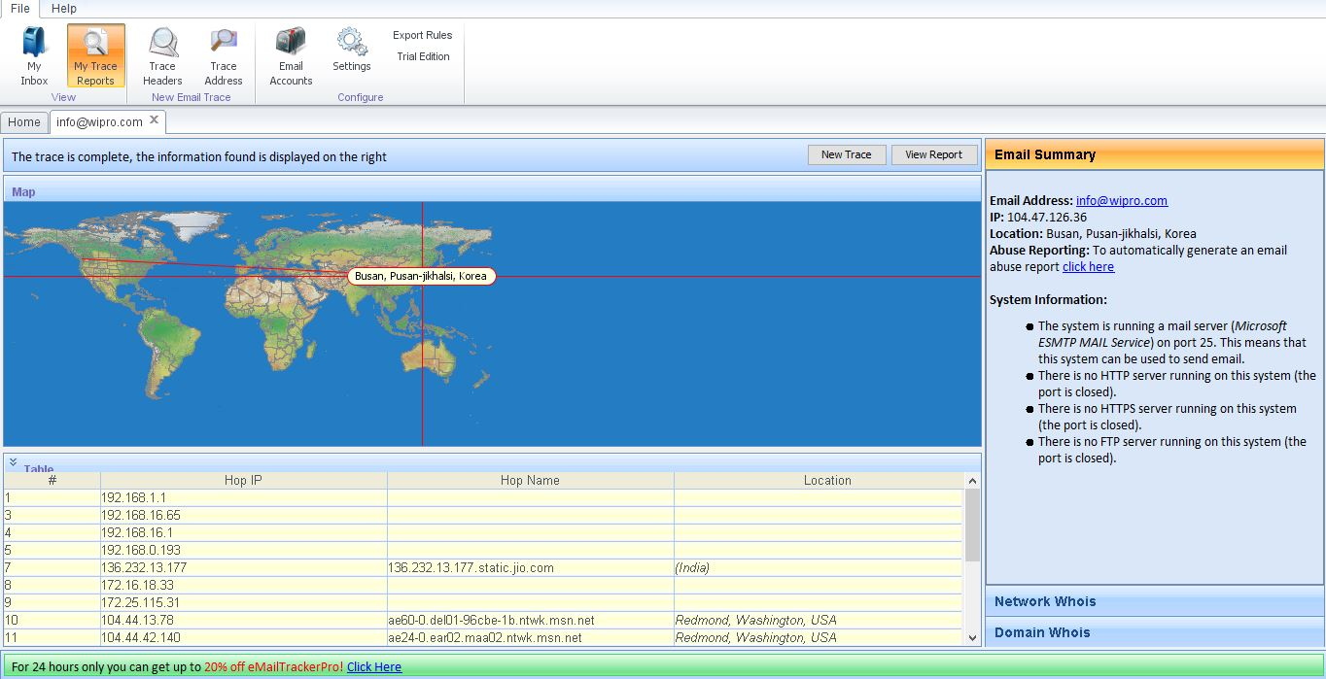

**Question 3:**

Scan and find out port numbers open 203.163.246.23

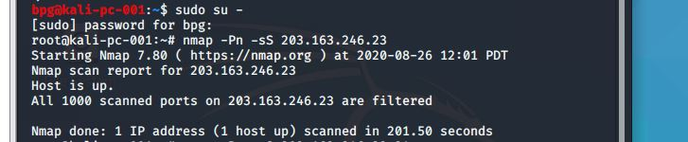

**Question 4:**

Install nessus in a VM and scan your laptop/desktop for CVE.

